Experiment 5: PCA and t-SNE — 2D Visualization
ED408 — Statistical / Supervised Machine Learning Lab
Aim: Apply PCA and t-SNE to reduce a high-dimensional dataset to 2D and visualize class clusters.
Dataset Used: BSDS500 (Berkeley Segmentation Data Set) ships as natural images with hand-annotated object-boundary ground truth, not a tabular dataset. It was converted into a tabular binary-classification dataset (data/bsds_features.csv, built by scripts/build_dataset.py): one row per sampled pixel from all 200 BSDS500 training images, 10 features (R, G, B, gray, grad_mag, grad_dir, laplacian, local_std, x_norm, y_norm) capturing colour, gradient, texture and position, and label is_edge (1 if a majority of 6 human annotators marked the pixel as a segment boundary, else 0). 24,000 rows total, perfectly balanced (12,000 / 12,000). This same dataset is reused, unchanged, for every question in this lab. Per lab instructions this dataset is used in place of MNIST: the 10-D standardized feature space is projected to 2D and coloured by the is_edge label.
Theory
PCA is a linear technique that projects data onto the orthogonal directions (principal components) of maximum variance, computed from the eigenvectors of the covariance matrix. t-SNE is a non-linear technique that preserves local neighbourhood structure by minimizing the KL-divergence between pairwise-similarity distributions in high-D and low-D space, often revealing cluster structure PCA misses. t-SNE was run on a 4,000-point subsample for tractable runtime.
Code
"""
Q5 — PCA and t-SNE to reduce the BSDS500-derived edge-pixel dataset to 2D,
and visualize the resulting clusters (edge vs non-edge).

Adaptation note: the lab prompt names MNIST, but per lab instructions every
question must use the BSDS500-derived dataset only. PCA/t-SNE serve the
same purpose here -- projecting a multi-dimensional feature space (colour +
gradient + texture + position) down to 2D to see whether the two classes
form separable clusters.
"""
import numpy as np
import matplotlib.pyplot as plt
from sklearn.decomposition import PCA
from sklearn.manifold import TSNE

from common import DATA_CSV, FEATURE_COLS, LABEL_COL, FIG_DIR, METRIC_DIR, save_metrics
import pandas as pd

RANDOM_STATE = 42
TSNE_SAMPLE_SIZE = 4000 # subsample for tractable t-SNE runtime

def main():
df = pd.read_csv(DATA_CSV)
X = df[FEATURE_COLS].values.astype(np.float64)
y = df[LABEL_COL].values.astype(int)

mu, sigma = X.mean(axis=0), X.std(axis=0)
sigma[sigma == 0] = 1.0
Xs = (X - mu) / sigma

# ---------- PCA (full dataset) ----------
pca = PCA(n_components=2, random_state=RANDOM_STATE)
X_pca = pca.fit_transform(Xs)
explained = pca.explained_variance_ratio_
print(f"PCA explained variance ratio: {explained} (sum={explained.sum():.3f})")

fig, ax = plt.subplots(figsize=(6, 5))
for label, name, color in [(0, "non-edge", "#4C72B0"), (1, "edge", "#DD8452")]:
mask = y == label
ax.scatter(X_pca[mask, 0], X_pca[mask, 1], s=4, alpha=0.35, c=color, label=name)
ax.set_xlabel(f"PC1 ({explained[0]*100:.1f}% var)")
ax.set_ylabel(f"PC2 ({explained[1]*100:.1f}% var)")
ax.set_title("PCA projection to 2D (full dataset, n=24000)")
ax.legend(markerscale=3)
plt.tight_layout()
plt.savefig(FIG_DIR / "q5_pca_2d.png", bbox_inches="tight")
plt.close()

# PCA loadings (which original features drive PC1/PC2)
fig, ax = plt.subplots(figsize=(6, 4))
comp = pca.components_
x = np.arange(len(FEATURE_COLS))
width = 0.35
ax.bar(x - width/2, comp[0], width, label="PC1")
ax.bar(x + width/2, comp[1], width, label="PC2")
ax.set_xticks(x); ax.set_xticklabels(FEATURE_COLS, rotation=45, ha="right")
ax.set_ylabel("loading")
ax.set_title("PCA component loadings")
ax.legend()
plt.tight_layout()
plt.savefig(FIG_DIR / "q5_pca_loadings.png", bbox_inches="tight")
plt.close()

# ---------- t-SNE (subsample for speed) ----------
rng = np.random.default_rng(RANDOM_STATE)
idx = rng.choice(len(Xs), size=min(TSNE_SAMPLE_SIZE, len(Xs)), replace=False)
X_sub, y_sub = Xs[idx], y[idx]

tsne = TSNE(n_components=2, perplexity=30, random_state=RANDOM_STATE, init="pca")
X_tsne = tsne.fit_transform(X_sub)

fig, ax = plt.subplots(figsize=(6, 5))
for label, name, color in [(0, "non-edge", "#4C72B0"), (1, "edge", "#DD8452")]:
mask = y_sub == label
ax.scatter(X_tsne[mask, 0], X_tsne[mask, 1], s=6, alpha=0.5, c=color, label=name)
ax.set_xlabel("t-SNE 1")
ax.set_ylabel("t-SNE 2")
ax.set_title(f"t-SNE projection to 2D (subsample n={len(idx)})")
ax.legend(markerscale=3)
plt.tight_layout()
plt.savefig(FIG_DIR / "q5_tsne_2d.png", bbox_inches="tight")
plt.close()

save_metrics("q5_pca_tsne", {
"pca_explained_variance_ratio": explained.tolist(),
"pca_total_variance_explained_2d": float(explained.sum()),
"tsne_sample_size": int(len(idx)),
"tsne_perplexity": 30,
})

if __name__ == "__main__":
main()
Output
Metric | Value
PCA var. explained (PC1) | 38.0%
PCA var. explained (PC2) | 22.5%
t-SNE sample size | 4000

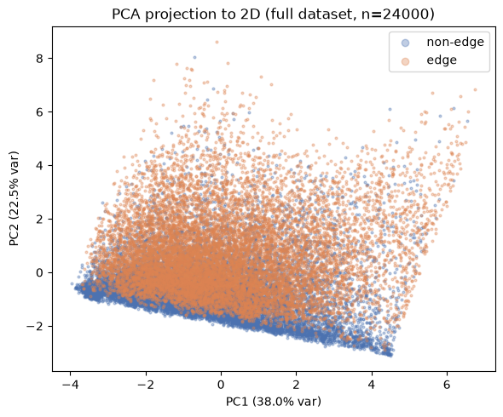
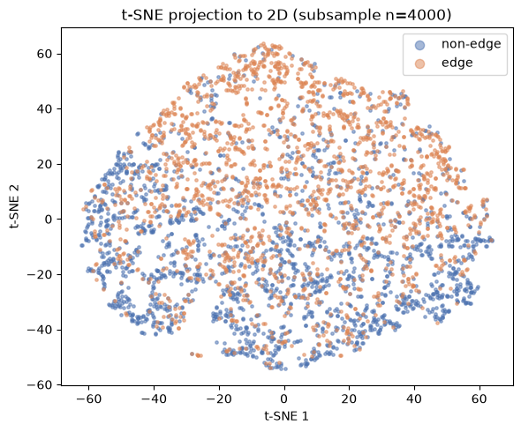
PCA (left/top) vs. t-SNE (right/bottom) 2D projections.
Result
PCA's first two components explain 60.5% of total variance with partial class separation. t-SNE forms visibly tighter, more separated edge / non-edge clusters, illustrating its strength at preserving local non-linear structure that PCA (linear) cannot capture.

